YELLOW — Operations Practice Questions
Syllabus points: 1. The transformation process (4 V's) · 2. Monitoring, control and improvement · 3. Overcoming resistance to change · 4. Transformed resources · 5. Transforming resources · 6. Environmental sustainability and social responsibility. Questions are unchanged, exactly as they appear in the original papers.

1. The transformation process — volume, variety, variation in demand, visibility
Reddam Trial 2023 — Question 21 (d) (4 marks)
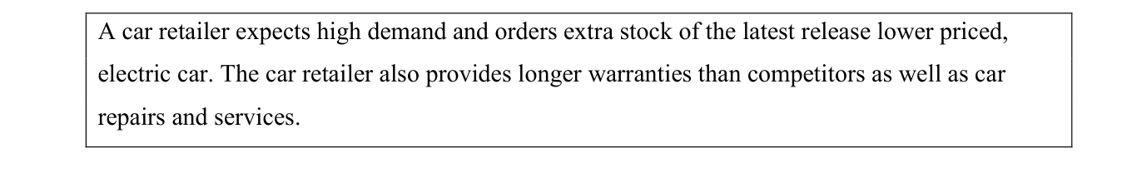
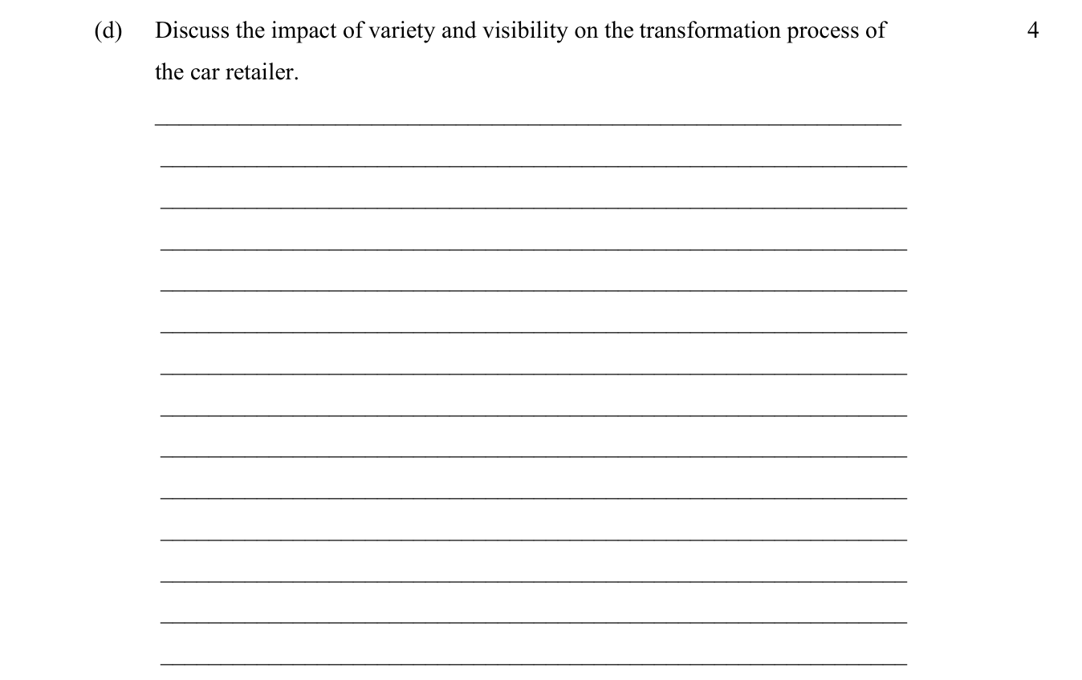
2019 HSC — Question 24 (b) (4 marks)
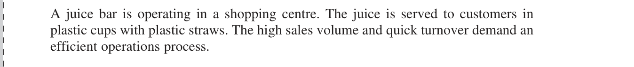
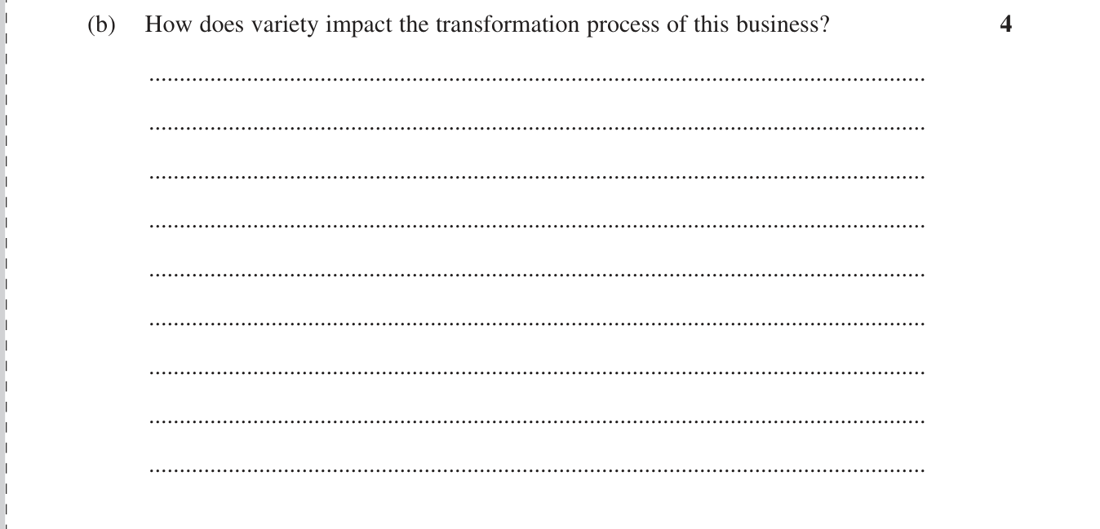

2. Monitoring, control and improvement
Closest short answer in your papers — see also the first multiple-choice question below, which is squarely this dot point.
Reddam Trial 2024 — Question 21 (d) (3 marks)
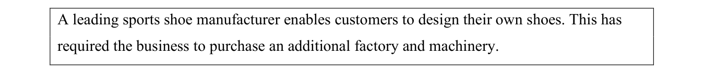
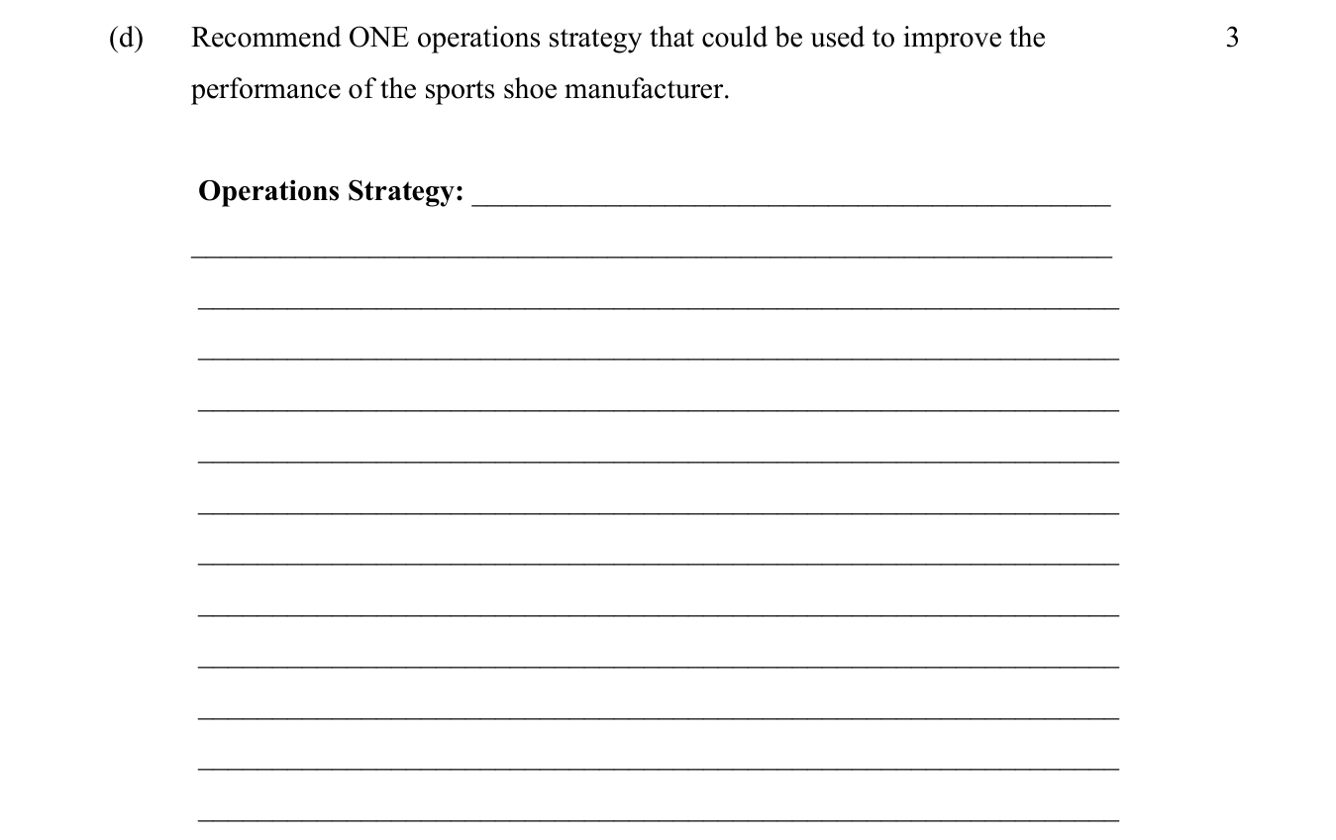

3. Overcoming resistance to change
2023 HSC — Question 21 (c) (5 marks)
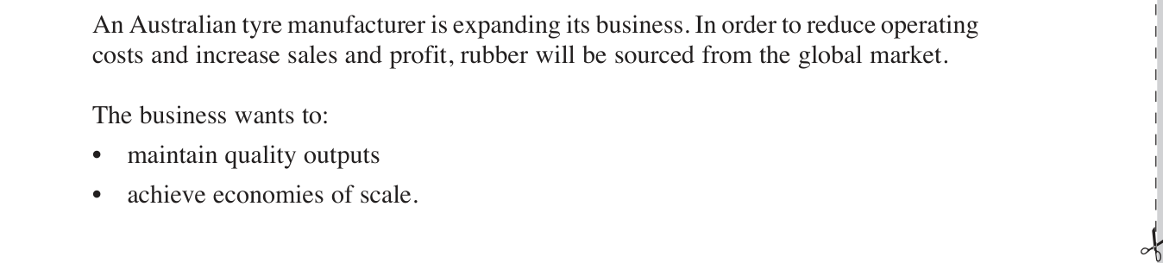
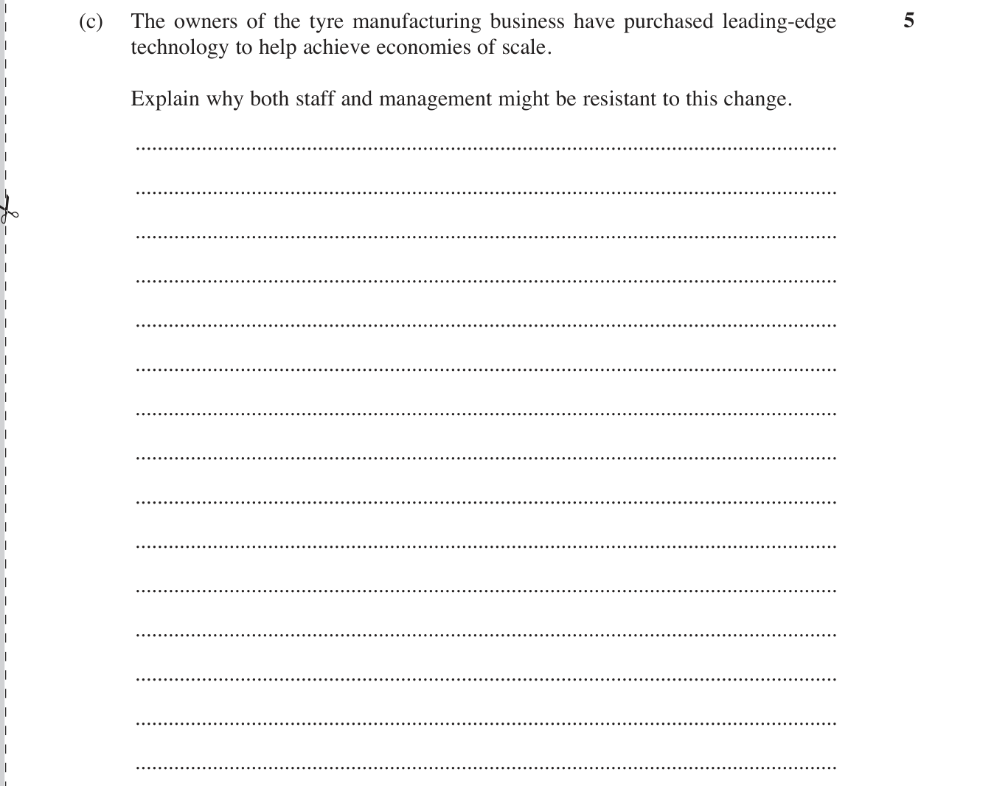
2023 BoS Trials — Question 25 (5 marks)
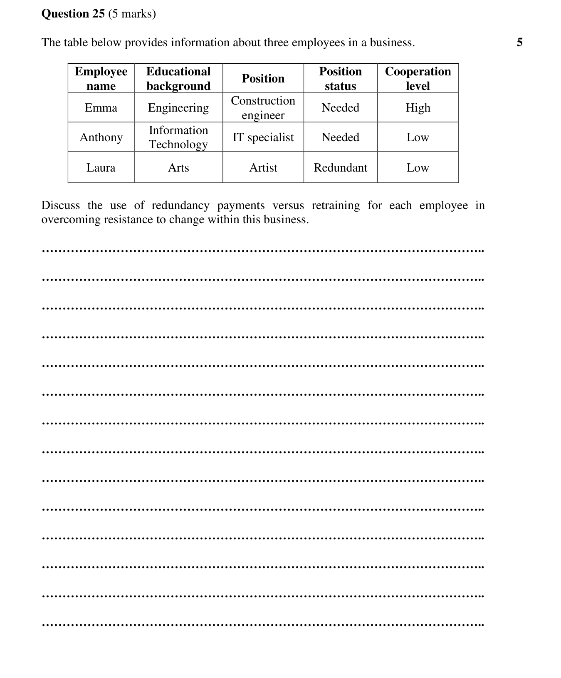

4. Transformed resources
2021 HSC — Question 21 (a) (2 marks)
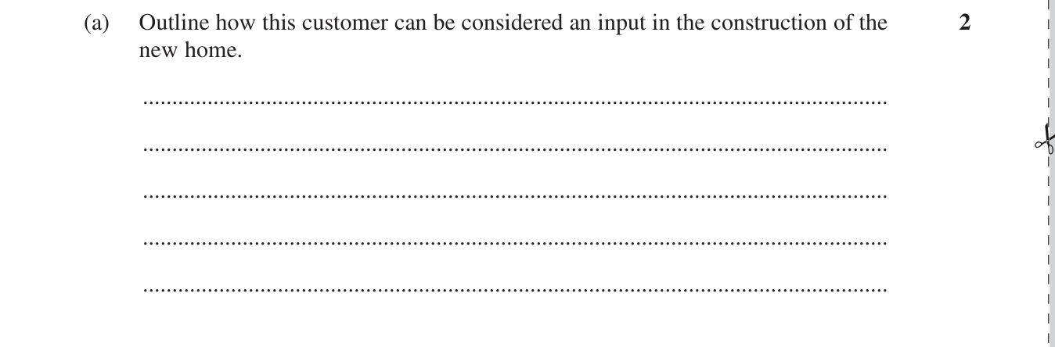
Roseville Trial 2023 — Question 21 (a) (2 marks)
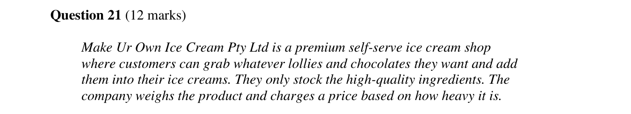
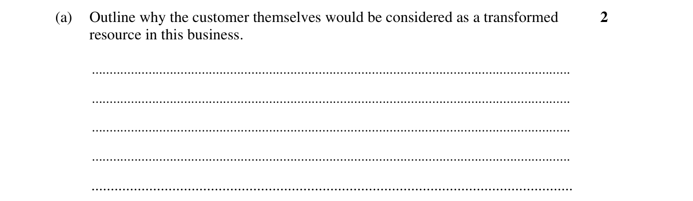

5. Transforming resources
2019 HSC — Question 24 (a) (2 marks)

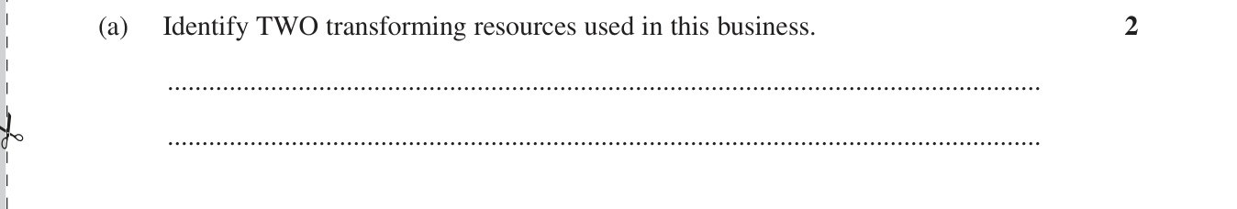
Barker Trial 2023 — Question 21 (a) (2 marks)
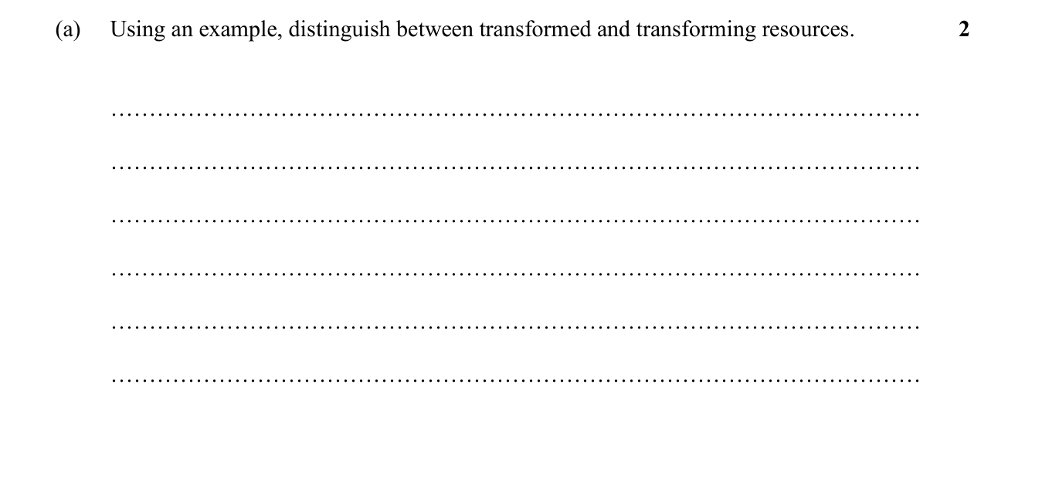

6. Environmental sustainability and social responsibility
SIC Trial 2024 — Question 21 (b) (4 marks)
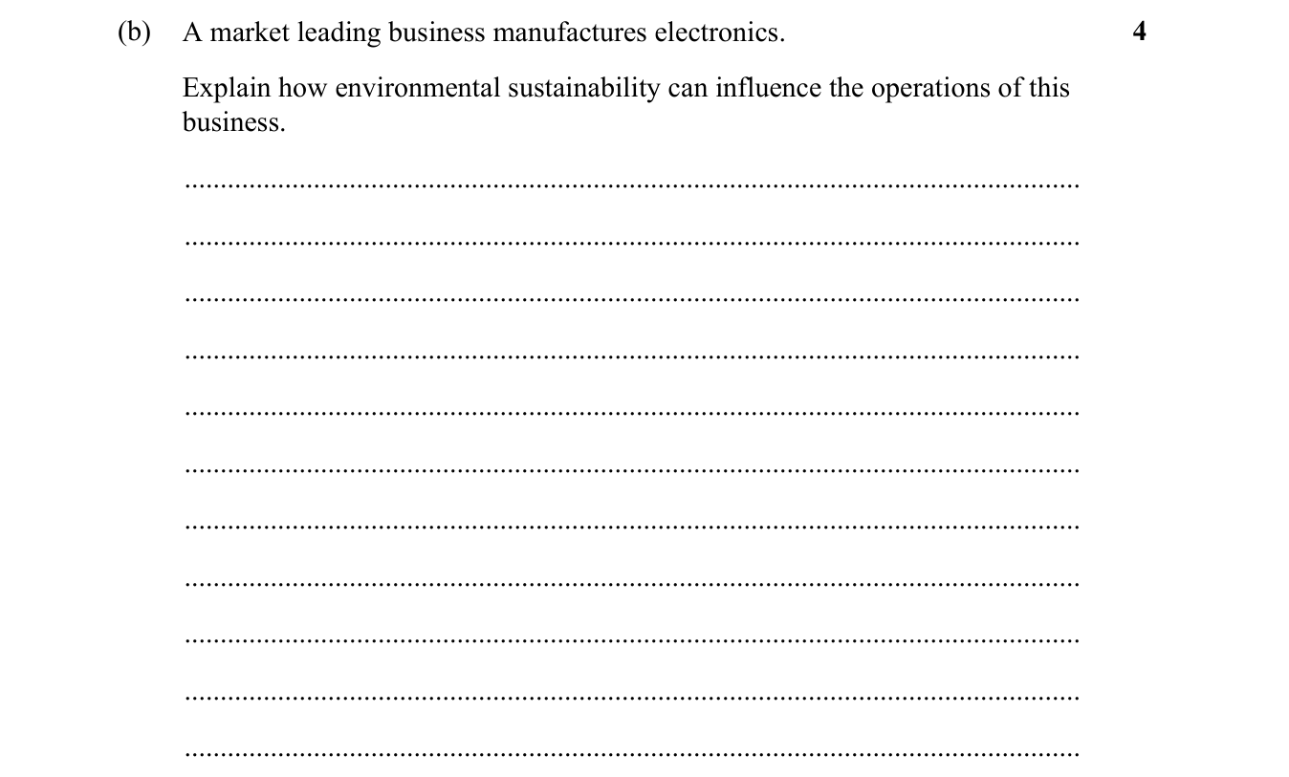
2019 HSC — Question 24 (c) (4 marks)

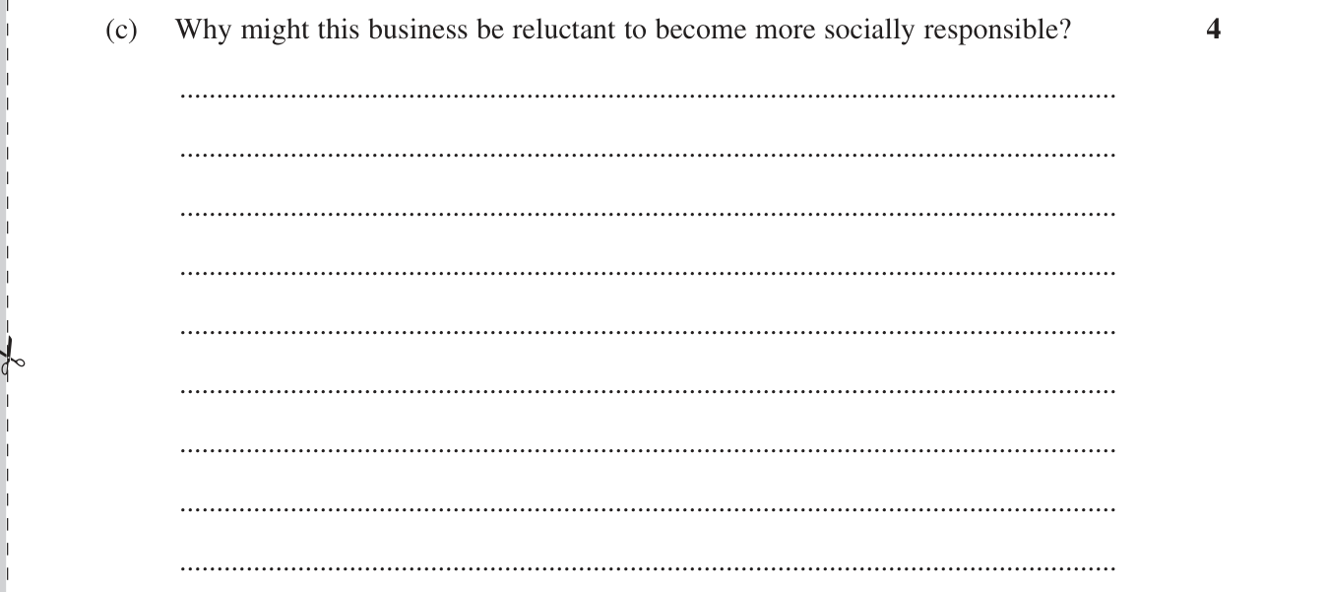

Multiple Choice
2020 HSC — Q16 — monitoring and improvement (1 marks)
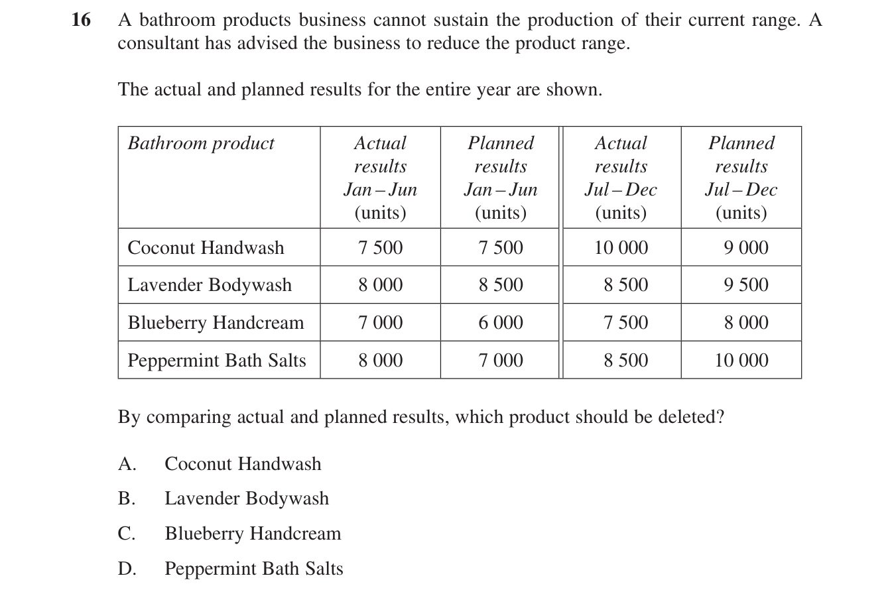
Reddam Trial 2024 — Q11 — transformed and transforming resources (1 marks)
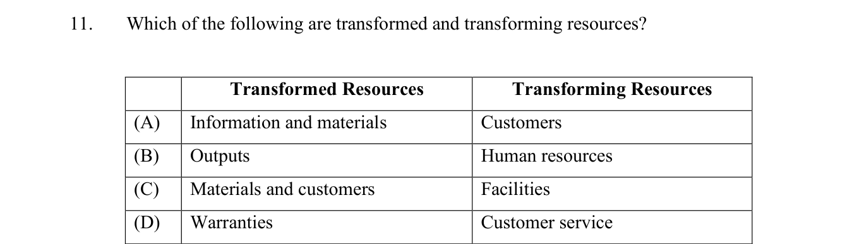
2021 HSC — Q12 — social responsibility (1 marks)
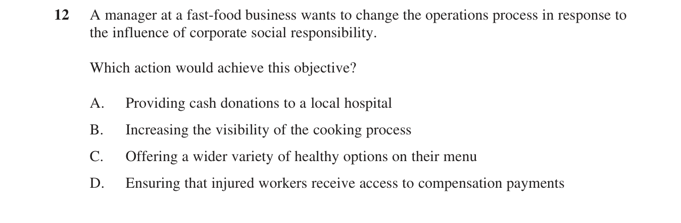

Extended Response
All operations extended responses from your papers that hit YELLOW points (business reports excluded).
2023 HSC — Question 27 — influences on operations (20 marks)
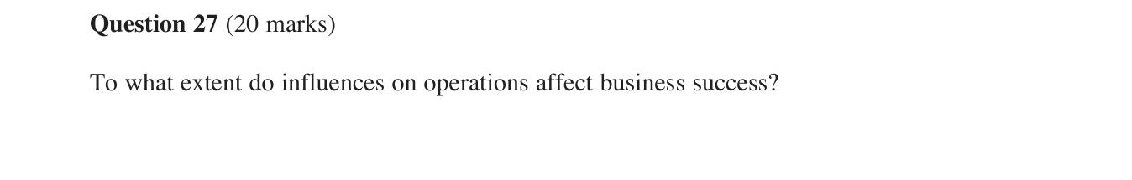
Roseville Trial 2024 — Question 27 — responding to influences on operations (20 marks)
